Network and Security Monitoring with Splunk and Nagios
Summary: Deploy a network and security event monitoring system using Splunk and Nagios to provide centralized visibility into system performance and potential threats across Windows and Linux environments.
Objectives: The purpose of the centralized monitoring system is to provide real time notification on system health metrics like CPU load, disk and memory usage, and network interface status, and detect potential security threats like repeated failed logins, privilege escalation, port scans and data exfiltration. I chose to use Splunk and Nagios because they have unique but complimentary strengths that enable comprehensive monitoring for a variety of different environments. Nagios provides real-time monitoring of the health of servers, applications and network devices, while Splunk is a SIEM that aggregates logs and provides advanced analytics to discover patterns and insights about your data.
Overview: For this project, Splunk and Nagios were deployed on a Ubuntu Server, which acted as the main log collector. The monitored environment included two VirtualBox VMs, a Ubuntu Desktop and Windows Server, and my home network’s router and the weather.com website. The NRPE (Nagios Remote Plugin Executor) monitoring agent was installed on the Ubuntu Desktop and the NCPA (Nagios Cross-Platform Agent) monitor agent was installed on the Windows Server. The monitoring agents were used to perform system health checks and forward logs to the main server.
Data Collection: Various log files on the Ubuntu and Windows machines were configured in the Splunk Universal Forwarding agents. The logs monitor configuration file changes/access, DNS requests, network traffic, system changes and security events. These logs are then sent to Splunk, indexed and categorized according to their sourcetype, which enables easier retrieval and analysis.
Logs monitored by Splunk on the Ubuntu Desktop:
-/var/log/audit/audit.log
-/var/log/dnsmasq.log
-/var/log/iptables.log
-/var/log/kern.log
-/var/log/secure
-/var/log/syslog
Logs monitored by Splunk on Windows Server:
-WinEventLog:Application
-WinEventLog:System
-WinEventLog:Security
-WinEventLog:Sysmon
- WinEventLog:Microsoft-Windows-DNS-Client/Operational
- WinEventLog:Microsoft-Windows-Sysmon/Operational
- C:\Windows\System32\LogFiles\Firewall\pfirewall.log

Monitoring Configuration: Nagios monitored system health and performance metrics on each client. When threshold levels are exceeded, a notification is sent by email.
Metrics Monitored on Ubuntu Desktop
Metric Monitored | Purpose | Threshold Level
CPU Load | Monitor CPU use to prevent overloading | Warning: 4 Tasks  Critical: 6 Tasks
Disk Use | Verify there is adequate storage space for future needs | Warning: 20%  Critical: 10%
Memory Use | Monitor RAM to prevent sluggish system performance | Warning: 80%  Critical: 90%
Network Interface Status | Verify network connectivity | Up / Down
System Uptime | To detect system crashes or monitor for scheduled reboots | Warning: 5 days  Critical: 10 days

Metrics Monitored on Windows Server
Metric Monitored | Purpose | Threshold Level
CPU Load | Monitor CPU use to prevent overloading | Warning: 80%  Critical: 95%
Disk Use | Verify there is adequate storage space for future needs | Warning: 80%  Critical: 95%
Memory Use | Monitor RAM to prevent sluggish system performance | Warning: 80%  Critical: 90%
Network Interface Bytes Received | Monitor bandwidth to | Bytes Received on Interface (in MB)
System Uptime | To detect system crashes or monitor for scheduled reboots | Critical: 86400s

Metrics Monitored on Weather.com Website
Metric Monitored | Purpose | Threshold Level
HTTP connectivity | Verify the website is reachable by HTTP (port 80) | Reachable/ Not Reachable
HTTPS connectivity | Verify the website is reachable by HTTPS (port 443) | Reachable / Not Reachable
Website Response Time | Monitor website availability and delay time | Warning: 5 seconds  Critical: 7 seconds

Metrics Monitored on Router
Metric Monitored | Purpose | Threshold Level
Interface Availability (Ping) | Verify the network’s default gateway is up so packets can be forwarded | Warning: 100ms or 20% packet loss  Critical: 500ms or 60 % packet loss

Event Analysis: Suspicious events were detected in the network using the Splunk log search feature. Suspicious security events include repeated failed logins, privilege escalation, critical file access, port scans, unusual IP addresses, logins outside of working hours and large data transfers.
Summary of Potential Security Events Detected During 2 Week Period
Failed Sudo Attempts | 12
Number of times Critical Configuration Files Accessed | 13
Port Scans | 23
Unusual Source IP Addresses | 37
Logins Outside Working Hours | 38
Count of Top 5 Largest Packet Sizes | 6,949

Number of Failed Sudo Attempts by User (12)
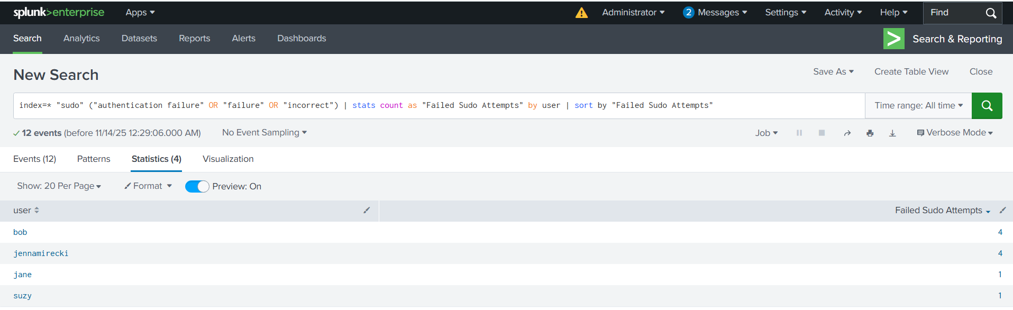
Critical File Access Attempts (13)
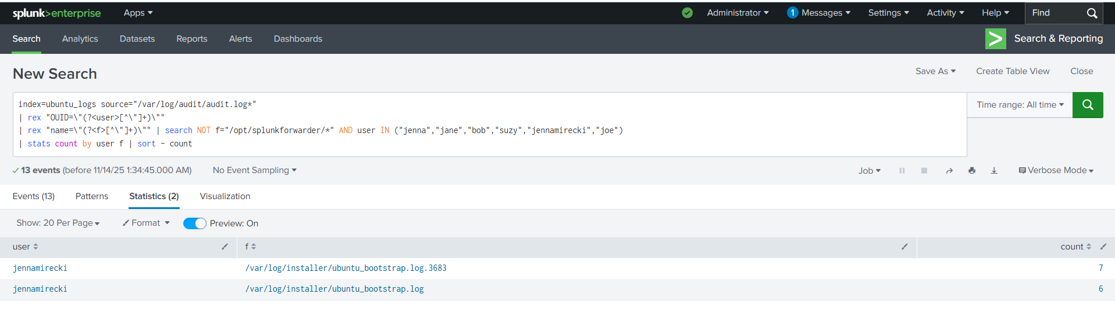

Detected Port Scans (23)
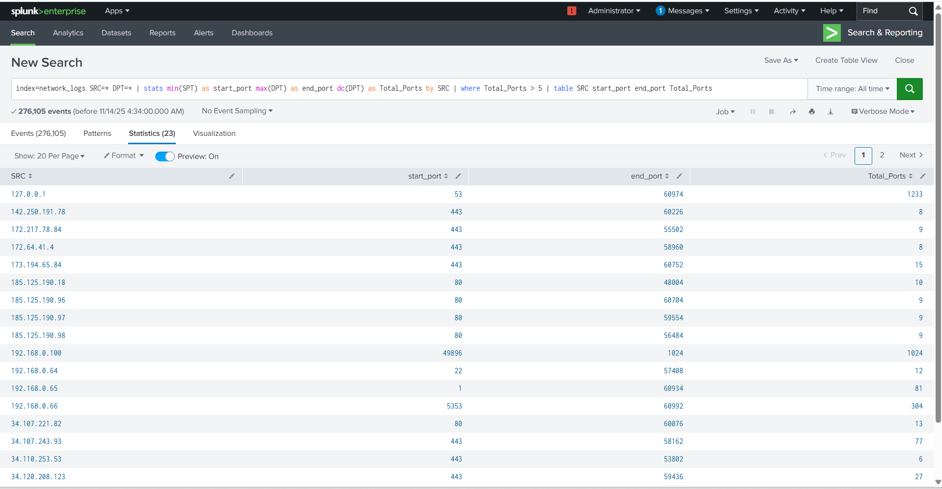
Unusual Source IP Addresses (37)
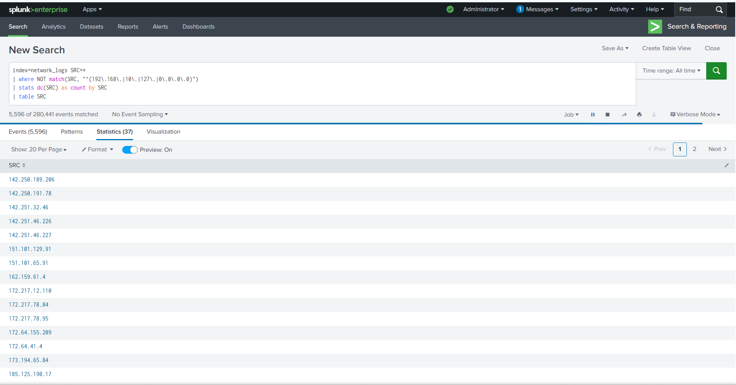

Top 5 Largest Packets by Count (Possible Data Exfiltration) (6,949)
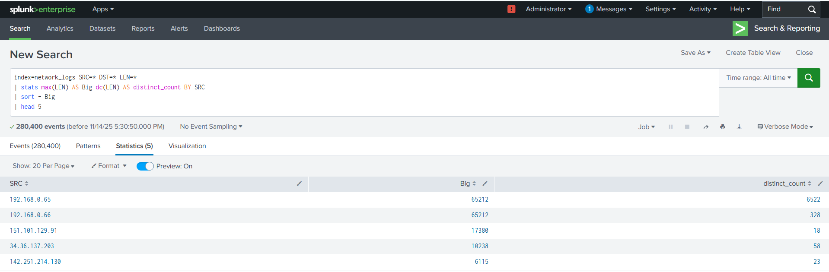
Logins Outside Working Hours 8AM – 5PM (38)
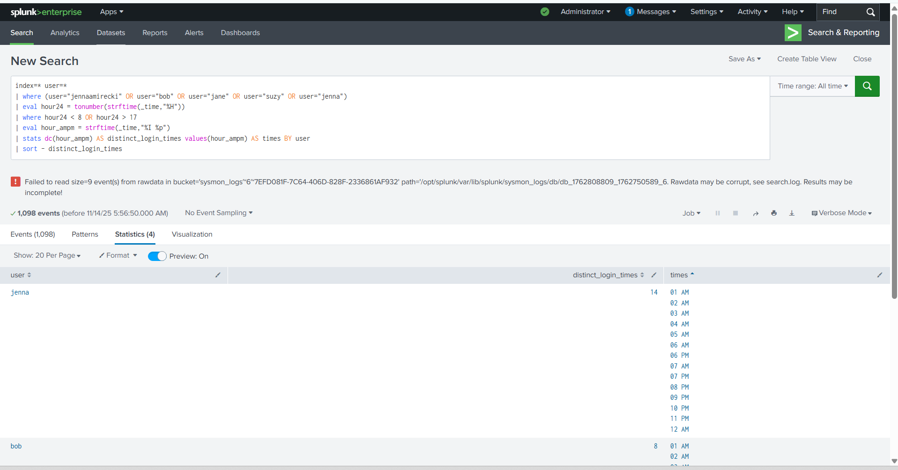
Incident Response: To monitor for potential security threats, I configured alerts to detect failed sudo attempts, logins outside working hours and unusually large packet sizes being transferred out of the network. For failed sudo attempts and large data transfers, alerts were sent to the Splunk application, but logins outside working hours were recorded in an event log.
Alerts Configured in Splunk
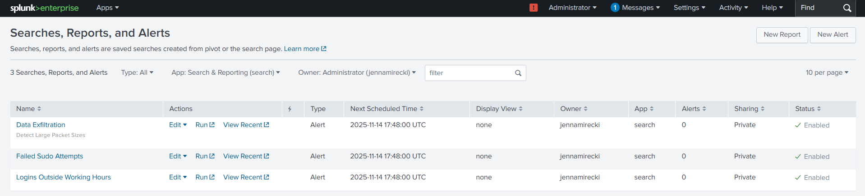
Visualization and Reporting: To support real-time monitoring and threat detection, I created two dashboards in Splunk Dashboard Studio. Each dashboard consolidates key metrics and security indicators in a single location, helping to effectively monitor network performance and protect against threats.
1.Resource Use Dashboard
The Resource Use Dashboard monitors system health in real time and helps identify performance bottlenecks or unusual system behavior.
Charts and Tables included:
-Avg CPU Load – monitors CPU usage to detect high utilization
-Avg RAM Use – monitors memory consumption
-Average Free Memory (GB) – tracks available memory
-System Uptime – calculates how long since each host was last rebooted
-Disk Space Used v Free – Visualizes how much Disk space is available
-Top 5 Users – identifies most frequent users on both hosts
-Top Destination Ports – identifies the most common destination ports
2.Security Monitoring Dashboard
The Security Monitoring Dashboard identifies malicious network activity by analyzing authentication logs, DNS queries and network traffic.
Charts and Tables included:
-Top 5 Suspicious Domains Queried – identifies DNS queries to domains with long domain names or unusual TLDs
-Denied Network Traffic – tracks number of dropped or denied packets
-Percentage of Unusual Ports – identifies the percent of network traffic to nonstandard ports
-Failed Login Count by User – calculates number of failed logins by user
-Logins During Past 24H – visualizes the number of logins by users during and outside of working hours
-Top 5 Biggest Packets Transferred Over Network – identifies the largest data transfers in the network
Conclusion: This project demonstrates how Splunk and Nagios work together to provide real-time comprehensive network and security monitoring services. Nagios helped monitor key system health metrics while Splunk consolidated logs and analyzed events across multiple environments, enabling complete coverage of network and system events. By collecting logs from Linux, Windows, a public website, and my router, I was able to establish a monitoring system capable of detecting abnormal system behavior, performance issues and potential security threats.
Appendix:
Nagios Services Dashboard
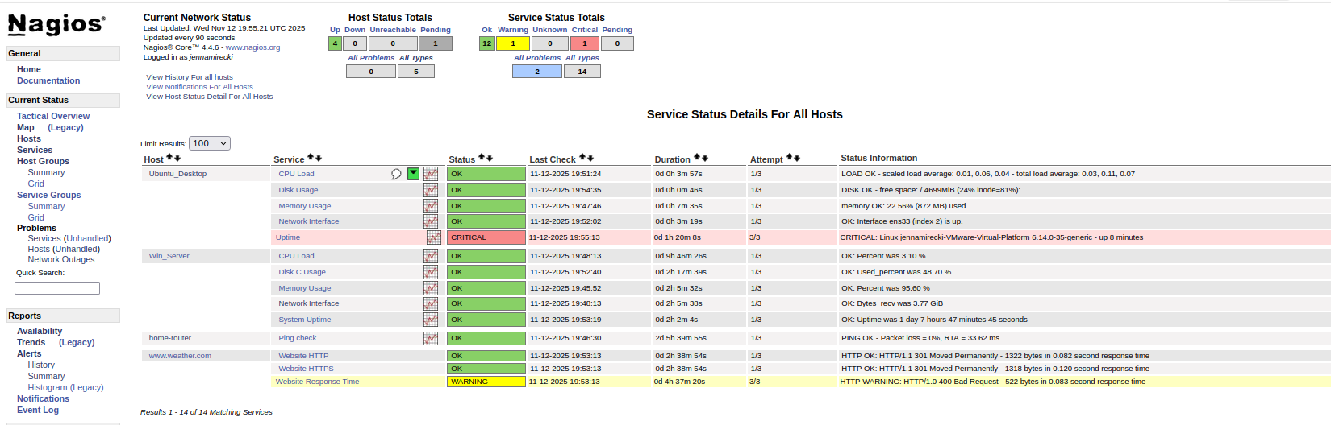
Splunk Resource Use Dashboard
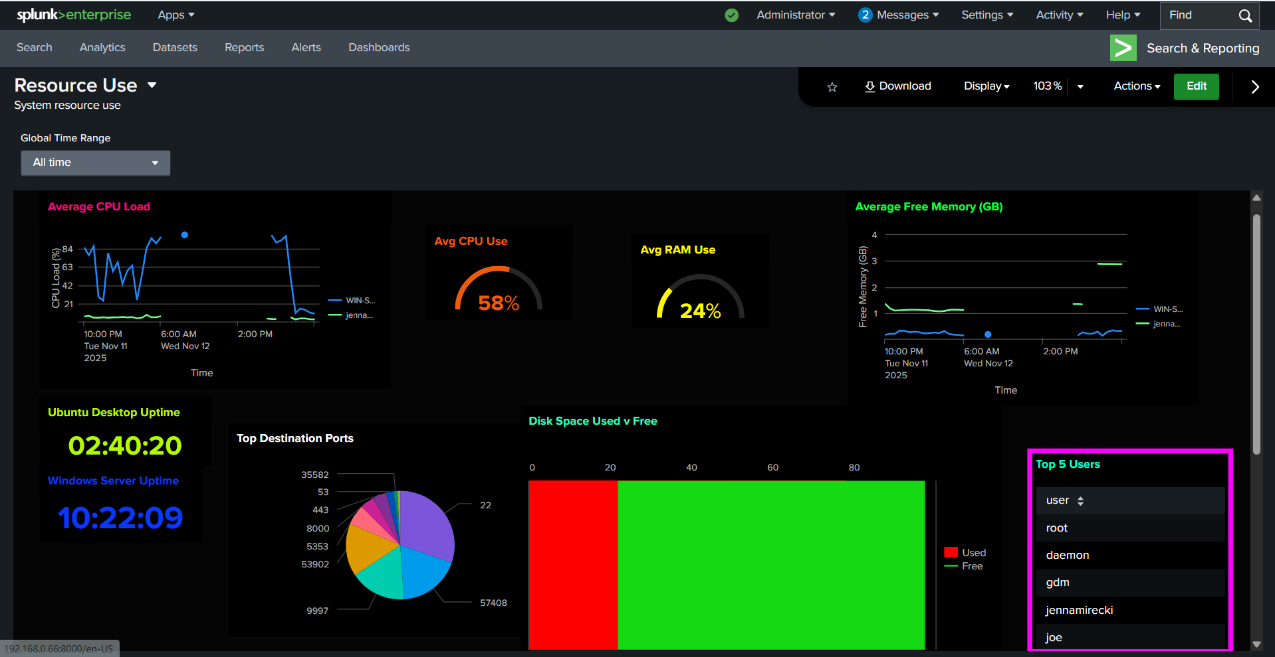

Splunk Security Monitoring Dashboard
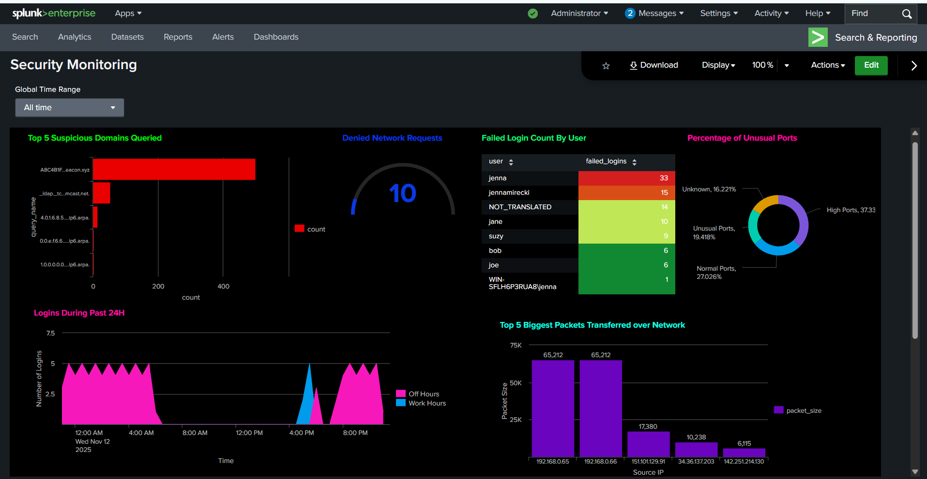
Nagios Server Hosts Configuration File
define host {
use linux-server
host_name Ubuntu_Desktop
alias Ubuntu Desktop
address 192.168.0.65
}
define host {
use windows-server
host_name Win_Server
address 192.168.0.64
}
define host {
use generic-router
host_name home-router
alias router1
address 192.168.0.1
}
define host {
use generic-host
host_name www.weather.com
alias Weather.com website
address www.weather.com
check_command check_host_http
}
Nagios Server Services Configuration File
define service {
use generic-service2
host_name www.weather.com
service_description Website HTTPS
check_command check_https_hostname! -S -C 30
}
define service {
use generic-service2
host_name www.weather.com
service_description Website HTTP
check_command check_httpname!
}
define service {
use generic-service2
host_name www.weather.com
service_description Website Response Time
check_command check_http2! -w 5 -c 7
}
define service {
use generic-service
host_name Ubuntu_Desktop
service_description CPU Load
check_command check_nrpe!check_load
}
define service {
use generic-service
host_name Ubuntu_Desktop
service_description Uptime
check_command check_nrpe!check_uptime
}
define service {
use generic-service
host_name Ubuntu_Desktop
service_description Memory Usage
check_command check_nrpe!check_memory
}
define service {
use generic-service
host_name Ubuntu_Desktop
service_description Disk Usage
check_command check_nrpe!check_disk
}
define service {
use generic-service
host_name Ubuntu_Desktop
service_description Network Interface
check_command check_nrpe!check_ens33
}
define service {
use generic-service
host_name home-router
service_description Ping check
check_command check_ping!100.0,20%!500.0,60%
}
define service {
use generic-service
host_name Win_Server
service_description CPU Load
check_command check_ncpa_custom!1234!cpu/percent!q=aggregate=avg!w=80!c=95
}
define service {
use generic-service
host_name Win_Server
service_description Memory Usage
check_command check_ncpa_custom!1234!memory/virtual/percent!w=80!c=90
}
define service {
use generic-service
host_name Win_Server
service_description Disk C Usage
check_command check_ncpa_custom!1234!disk/logical/C:|/used_percent!w=80!c=95
}
define service {
use generic-service
host_name Win_Server
service_description System Uptime
check_command check_ncpa_custom!1234!system/uptime!c=86400
}
define service {
use generic-service
host_name Win_Server
service_description Network Interface
check_command check_ncpa_custom!1234!interface/Ethernet0/bytes_recv!d!u=M
}
Windows Server - NCPA Inputs Configuration File
inputs.conf
[WinEventLog://Application]
index = windows_logs
sourcetype = WinEventLog:Application
disabled = 0
[WinEventLog://System]
sourcetype = WinEventLog:System
index = windows_logs
disabled = 0
[WinEventLog://Security]
sourcetype = WinEventLog:Security
index = windows_logs
disabled = 0
[WinEventLog://Microsoft-Windows-DNS-Client/Operational]
disabled = 0
index = dns_logs
sourcetype = XmlWinEventLog:Microsoft-Windows-DNS-Client/Operational
[WinEventLog://Microsoft-Windows-Sysmon/Operational]
disabled = 0
index = sysmon_logs
sourcetype = XmlWinEventLog:Microsoft-Windows-Sysmon/Operational
[WinEventLog://Setup]
sourcetype = WinEventLog:Setup
disabled = 0
index = windows_logs
[monitor://C:\Windows\System32\LogFiles\Firewall\pfirewall.log]
index = network_logs
disabled = 0
sourcetype = WinFirewall

